Lab 1 – Check Hadoop Cluster health

# Login to CM web UI

* Login to CM

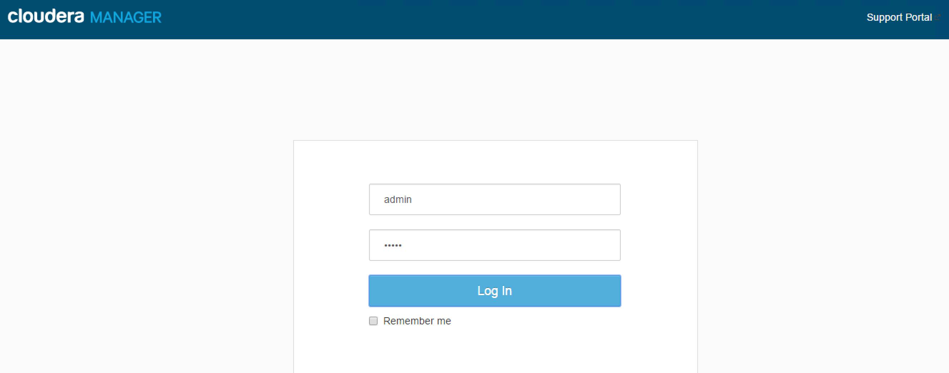

* Validate all services are in good health status, if not fix the issues prior to proceeding

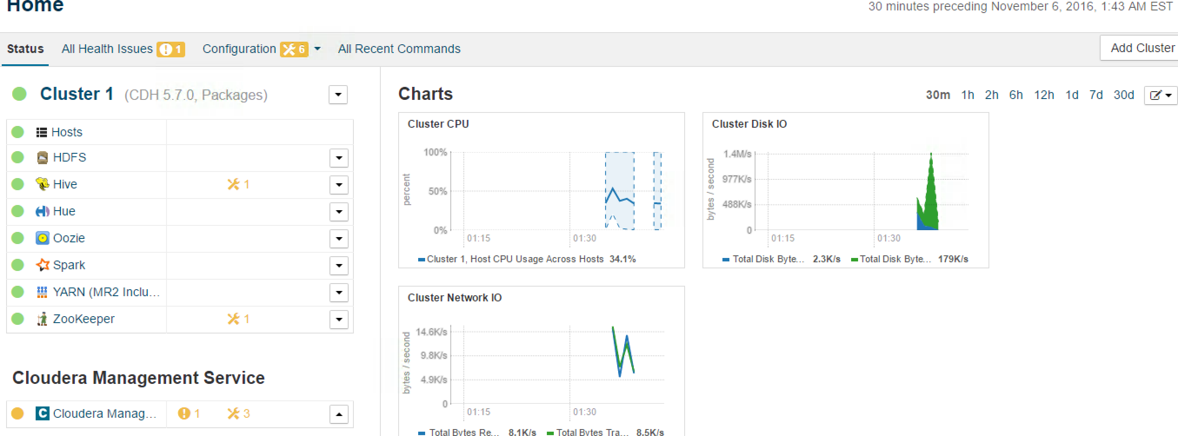

# Login to CM node and execute health check script

* Login to Cloudera manager node from command
* Download script from
* Execute script “hdfs_check_cluster.sh” as hdfs user
  + Download script from: [hdfs_check_cluster.sh](https://raw.githubusercontent.com/abdul-git/hadoop-advance/master/session1/hdfs_check_cluster.sh)
  + Script must be executed as hdfs user

|  |
| --- |
| sudo su – hdfs |

* + Execute script – hdfs_check_cluster.sh

|  |
| --- |
| ./hdfs_check_cluster.sh |

* + Script will test the health of cluster and execute some base test.
    - Verify cluster heath
    - Displays cluster topology
    - Check whether cluster is in Safemode or not
    - Execute test MapReduce job
    - Executes Hive Test
    - Execute cluster quick benchmark